Glasgow Recovery Communities: COVID-19 (Coronavirus)

Glasgow Recovery Community cafes, groups and initiatives are
suspended until further notice.

We are providing continued support via telephone and on-line services.

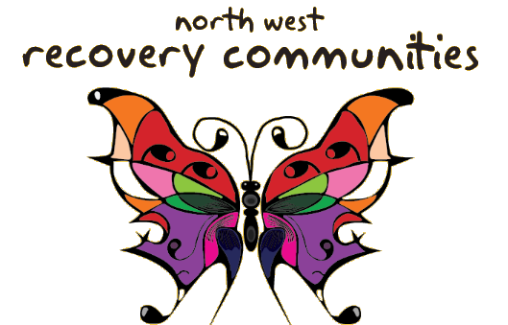  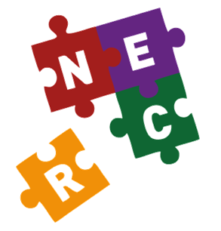 | North West Recovery Community  nwrc-glasgow.co.uk | 0141 328 4578  07590 440861
 | North East Recovery Community  North-East-Recovery-Community.co.uk | 0141 556 3951  07970 651103
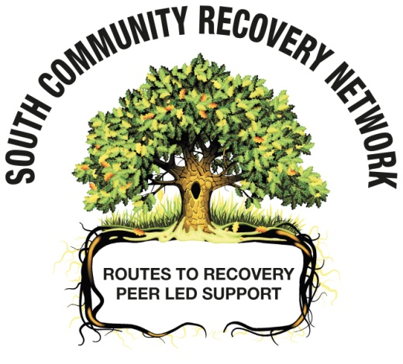 | South Community Recovery Network  scrn-recovery.co.uk | 0141 429 8181  07383 868129
 | North West Recovery Hub  North East Recovery Hub | 0808 178 5901  0808 164 4261
 | South Recovery Hub | 0141 423 5872
On-line support Services

We are providing on-line check-ins and recovery meetings through GOOGLE MEET on-line. Contact your local recovery community for details.

Check-ins 10:00 am Monday - Sunday
Recovery Meetings 2:00 pm Monday - Sunday

Additional on-line support:

Psychcentral SMART, Mutual Aid, N/A, A/A
https://blogs.psychcentral.com/sex/2020/03/online-addiction-recovery-resources-for-use-during-the-covid-19-pandemic/#.XnCbOZWM33U.facebook

A/A on-line http://www.aa.org/
N/A on-line http://www.na.org/

In The Rooms free online recovery tool offering 130 weekly online meetings:
12 Step, Non-12 Step, Wellness and Mental Health.
https://www.intherooms.com/home/

The Recovery Consultants
https://www.facebook.com/therecoveryconsultants/

