Captioning

Tonight’s performance has captions available via The Difference Engine App or The Difference Engine Wifi network. The App is the best way to access the captions.

Scan the QR code to download the App

Apple:  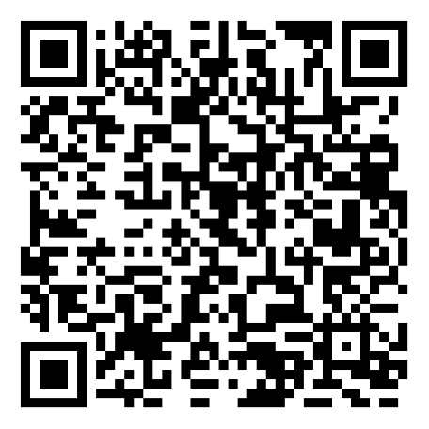  Then: | Android:  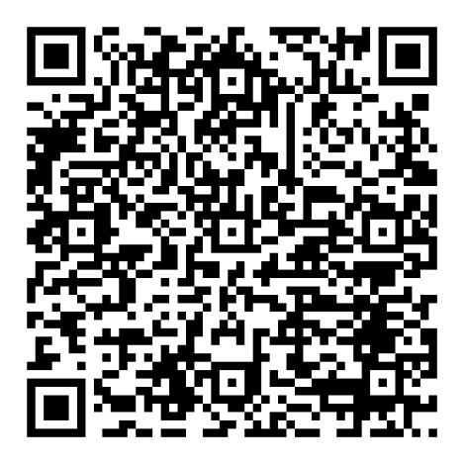 | Amazon: 
- Turn on Airplane mode on your phone
- Go to Wifi and select the Difference Engine network – password is engine123
- Select Captions

If you have an older phone or cannot download the app:

- Go to Wifi and select the Difference Engine network
- Open your internet browser
- Type 192.168.0.105 and press enter
- Select Captions

